**IDEATION REPORT**

**Gas Leakage Monitoring and Alerting System**

*VIJAYALAKSHMI , BALAYOGESH ,DHAYAMOORTHI ,SWETHA*

# Abstract

Internet of Things aim towards making life simpler by automating every small task around us. As much is IoT helping in automating tasks, the benefits of IoT can also be extended for enhancing the existing safety standards. Safety, the elementary concern of any project, has not been left untouched by IoT. Gas Leakages in open or closed areas can prove to be dangerous and lethal. The traditional Gas Leakage Detector Systems though have great precision, fail to acknowledge a few factors in the field of alerting the people about the leakage. Therefore we have used the IoT technology to make a Gas Leakage Detector for society which having Smart Alerting techniques involving sending text message to the concerned authority and an ability performing data analytics on sensor readings. Our main aim is to proposing the gas leakage system for society where each flat have gas leakage detector hardware. This will detect the harmful gases in environment and alerting to the society member through alarm and sending notification.

# Introduction

Internet of Things aim towards making life simpler by automating every small task around us. As much is IoT helping in automating tasks, the benefits of IoT can also be extended for enhancing the existing safety standards. Safety has always been an important criterion while designing home, buildings, industries as well as cities. The increased concentration of certain gases in the atmosphere can prove to be extremely dangerous. These gases might be flammable at certain temperature and humidity conditions, toxic after exceeding the specified concentrations limits or even a contributing factor in the air pollution of an area leading to problems such as smog and reduced visibility which can in turn cause severe accidents and also have adverse effect on the health of people. Most of the societies have fire safety mechanism. But it can use after the fire exists. In order to have a control over such conditions we proposed system that uses sensors which is capable of detecting the gases such as LPG, CO2, CO and CH4. This system will not only able to detect the leakage of gas but also alerting through audible alarms. Presence of excess amounts of harmful gases in environment then this system can notify the user. System can notify to society admin about the condition before mishap takes place through a message.

System consists of gas detector sensors, Arduino board, ESP8266 and Cloud server. One Society authority person can register the all flat member user to our system. Society admin can add the details of per flat user such as user name, mobile number, per user flat sensor details information. Society admin can configure the threshold value of each sensor. System hardware can be deployed on each flat. Sensors can sense the value per time. System can send the values to cloud server. Server can Check that the sensor values was existed the threshold value. If sensor value can cross the limit the server can send the command to hardware for buzzing the alarm. Server also sends the notification message to user.

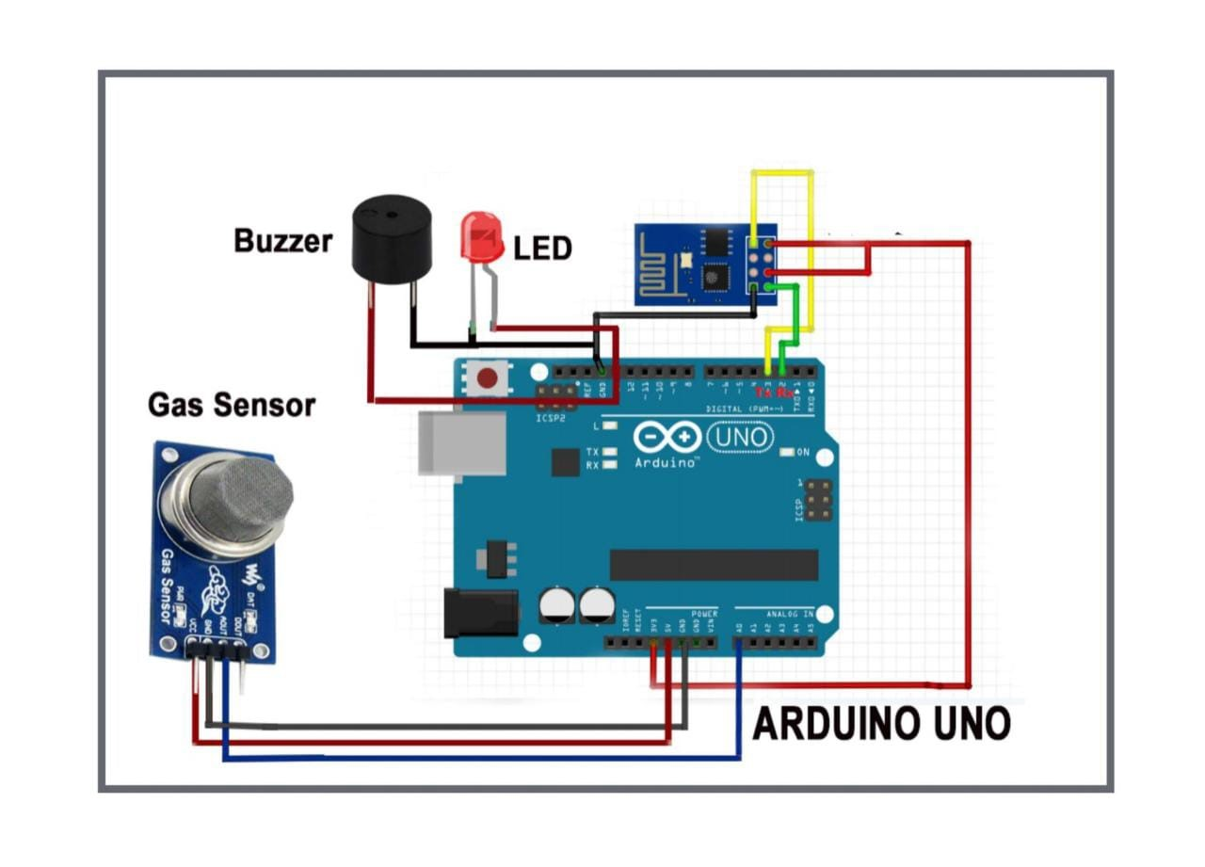

In this paper we use IOT technology for enhancing the existing safety standards. While making this prototype has been to bring a revolution in the field of safety against the leakage of harmful and toxic gases in environment and hence nullify any major or minor hazard being caused due to them. We have used the IOT technology to make a Gas Leakage Detector for society which having Smart Alerting techniques involving sending text message to the concerned authority and an ability performing data analytics on sensor. This system will be able to detect the gas in environment using the gas sensors. This will prevent form the major harmful problem.